We are recruiting for our online nutrition education program for people with multiple sclerosis (MS)
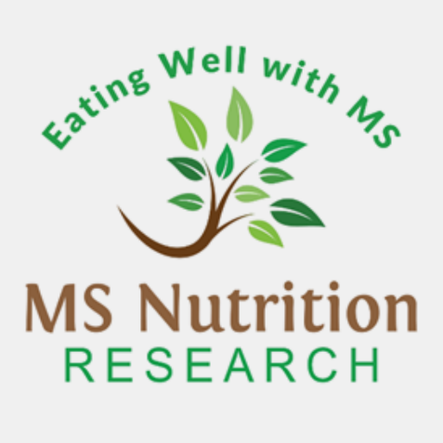



For more information email eatwellms@deakin.edu.au

Interested in learning about healthy eating for MS?
- Do you have MS?
- Do you live in Australia?
- Do you have access to the internet to complete a 6-week online program (around 1 hour per week in your own time) plus a 3-month refresher (around 1 hour)?
Researchers from Deakin University are looking for:
- Adults with MS who have not completed any online nutrition education programs, and
- who are not currently seeing a dietitian in relation to a health condition
to test an online nutrition education program for people with MS.

To sign up: https://msnutrition.org.au/

Or scan the QR code ->

This study has ethics approval from Deakin University (2024/HE000590)

